Highlights

GFD CONDUCTS MID-YEAR PLAN REVIEW OF SOME ACTIVITIES 3
- GFD Holds a staff and board meeting 3
- GFD and Light for the World train Disability Inclusion Facilitators 4
- GFD and GIZ Collaborate to Train Paralegals to Advance the Rights of Persons with Disabilities 6
- GFD Meets with the Speaker of Ghana’s Parliament to discuss amendments to Disability act. 7
- GFD Holds Reporting and Targeting Workshop for Staff 9
In the third and final module, participants were educated on how to conduct accessibility audits effectively. They were introduced to the essential tools and materials required for conducting such audits and gained familiarity with accessibility standards. 12
Diversity was a key feature of the workshop, with a total of 32 participants in attendance, comprising 18 males and 15 females. These participants represented various government institutions, including the Ministry of Local Government and Rural Development, the National Planning Development Commission, National Council on Persons with Disabilities, among others. 12
The inaugural remarks were delivered by Rita Kusi Kyerema, the Executive Director of GFD, setting the stage for the workshop. Rebecca Efua Nunoo, the Disability Inclusion Advisor, assumed the role of session moderator, fostering a sense of connection and engagement among participants. Facilitators Gideon Segbe and Moses Fordjour, with additional support from Nora Kankam Dadzie, led sessions and encouraged participants to engage in discussions and practical applications throughout the training program. 12
The training program stood out for its active participation and a strong commitment to learning, creating a dynamic and collaborative learning environment. Positive outcomes of the workshop encompassed the training of government agencies on the Ghana Accessibility Standard for the Built Environment. Demonstrations were also made to illustrate how accessible environments significantly enhance inclusion. Additionally, the workshop provided an outline of the processes involved in conducting accessibility audits 12
- The GFD convenes meeting with regional leaders 12
The meeting, which took place on September 22, 2023, saw the Vice President of GFD opening the session with an introductory statement, underscoring the urgency of the gathering. The focus of the meeting was to address pressing concerns regarding the National Health Insurance Scheme (NHIS) registration. 12
The officer responsible for NHIS membership registration of GFD provided an update to the participants, revealing that only 8% of the intended target of 800 individuals had been successfully registered or had their cards renewed. This low registration rate was met with disappointment among the participants. 12
The floor was then opened to participants, allowing them to share their concerns about the NHIS registration drive. 12
During the discussions, the Accra regional leader requested a detailed breakdown of the regions registered. Although the Greater Accra region had submitted their members' names for NHIS registration, they were yet to receive the registered cards. Furthermore, it came to light that the Oti Region had submitted 32 names to the federation, but none of them had been successfully registered, highlighting a significant challenge in the NHIS registration process. 12
The meeting concluded with a commitment from all parties to address these issues and improve the NHIS registration process for the benefit of all members. The meeting served as a step toward resolving the challenges facing the NHIS registration system within the GFD. 12
- Capacity Assessment Workshop Empowers Women's Wings of Disability Organizations. 14
- Success Story! 14

Capacity Assessment of 3 OPDs. SHARECARE, GAPA and GSPD
In an effort to empower and enhance the leadership capacity of Organizations of Persons with Disabilities (OPDs) in Ghana, the Ghana Federation of Disabilities (GFD) conducted an insightful assessment at the Paloma Hotel in Accra on July 3, 2023. The primary aim of this initiative was to identify gaps in leadership capacity within three prominent OPDs: ShareCare Ghana, Ghana Association of Persons with Albinism (GAPA), and Ghana Society of the Physically Disabled.
A total of 18 dedicated individuals actively participated in the assessment, furthering their commitment to the betterment of their respective organizations. The group consisted of 11 males and 7 females, all of whom shared a passion for driving positive change within their communities. This diversity and gender balance within the group reflect the inclusivity and commitment to gender equity that are key values in the disability rights movement.
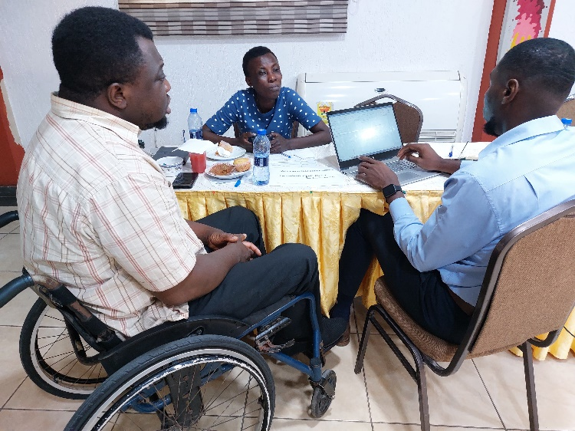
The assessment was generously funded by the Disability Persons Organizations of Ghana (DPOD), who recognize the importance of strengthening the leadership capabilities of OPDs as a means to advocate for the rights and wellbeing of persons with disabilities. In an effort to empower and enhance the leadership capacity of Organizations of Persons with Disabilities (OPDs) in Ghana, the Ghana Federation of Disabilities (GFD) conducted an insightful assessment at the Paloma Hotel in Accra on July 3, 2023. The primary aim of this initiative was to identify gaps in leadership capacity within three prominent OPDs: ShareCare Ghana, Ghana Association of Persons with Albinism (GAPA), and Ghana Society of the Physically Disabled.
A total of 18 staff of the 3 OPDs participated in the assessment, furthering their commitment to the betterment of their respective organizations. The group consisted of 11 males and 7 females, all of whom shared a passion for driving positive change within their organisations.
The assessment was funded by the DPOD, which recognizes the importance of strengthening the leadership capabilities of OPDs as a means to advocate for the rights and well-being of persons with disabilities.

GFD CONDUCTS MID-YEAR PLAN REVIEW OF SOME ACTIVITIES
In an effort to enhance the outcomes of various projects and activities, GFD convened a significant mid-term project plan review meeting. This gathering, which took place at the Paloma Hotel in Accra on July 4 and 5, 2023, brought together 27 participants. Among them were representatives from the Programs and finance departments of GFD, as well as members of Organisations of Persons with Disabilities (OPD).

This two-day meeting served as a platform for rigorous assessment, where the focus was squarely on improving efficiency, effectiveness, relevance, and to re strategize the approach of some activities to get the needed results. the overall impact of some activities. With a diverse array of stakeholders engaged, GFD is poised to forge ahead with renewed vigor, ensuring that the projects continue to meet their milestones.

GFD Holds a staff and board meeting

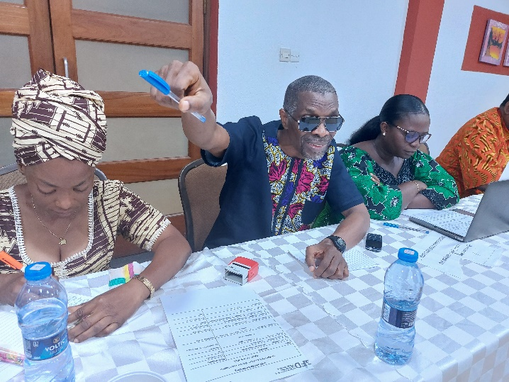
GFD organised a meeting on July 6, 2023, bringing together an assembly of board members and staff. This gathering served as a platform to elucidate and harmonize the expectations of both board members and staff, ultimately paving the way for a seamless operation and the continued success of GFD. Among the notable attendees were key figures like Mr. Joseph Atsu Homadzi, the President and Board Chairman of GFD, Madam Sirina, the Vice President, Martha Cofie, representing gender interests, and our esteemed Executive Director, Madam Rita Kusi Kyeremaa.
A picture of GFD Executives and at the staff and board members meeting.
During the meeting, the board's visionary goals and aspirations were communicated clearly to the staff, fostering a unified sense of purpose and direction. Meanwhile, staff members in turn, renewed their unwavering commitment to ensuring the effective functioning of GFD. Their collective dedication is the cornerstone upon which GFD continue to build a brighter future for persons with disabilities in Ghana.
Together, we remain resolute in our mission to enhance the lives of those we serve, underpinned by a shared commitment to making a meaningful impact and effecting positive change in our community.

GFD holds Capacity Building Training for Staff
On the 7th of July 2023, the Ghana Federation of Disability Organisations (GFD) held a training workshop at the Paloma Hotel, Accra. The event was a testament to GFD's commitment to enhancing the professional development of its staff members. This training represented the organization's ongoing efforts to strengthen its workforce and elevate the services it provides to the disability community in Ghana.
A picture of GFD staff with a sign language interpreter
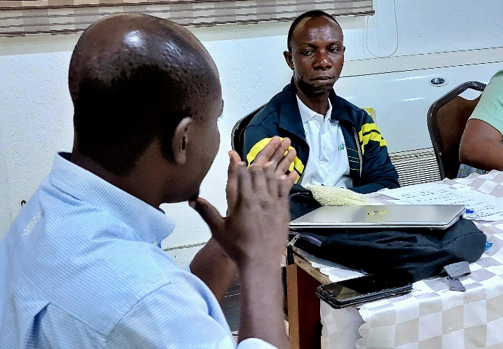
During this day-long workshop, participants learned about the intricacies of budget preparation and analysis. They were equipped with tools and insights into financial management, ensuring that every cedi allocated serves its intended purpose. Moreover, the training included a comprehensive exploration of best practices to uphold rigorous quality standards and methodologies for measuring performance outcomes. This approach not only equips GFD's staff with the skills and knowledge required to work effectively but also solidifies the organization's reputation as a leading force in disability advocacy and support in Ghana. This workshop was an integral component of GFD's broader capacity-building program, which aspires to elevate the overall efficiency and effectiveness of the organization's operations and services.

GFD and Light for the World train Disability Inclusion Facilitators

The Ghana Federation of Disability Organizations (GFD) and Light for the World came together to empower our newly hired Disability Inclusion Facilitators (DIFs) for the upcoming Mini Academy program on the “We can Work” project. On July 22, the training six days training was concluded with a sense of fulfilment and excitement for the positive impact ahead.
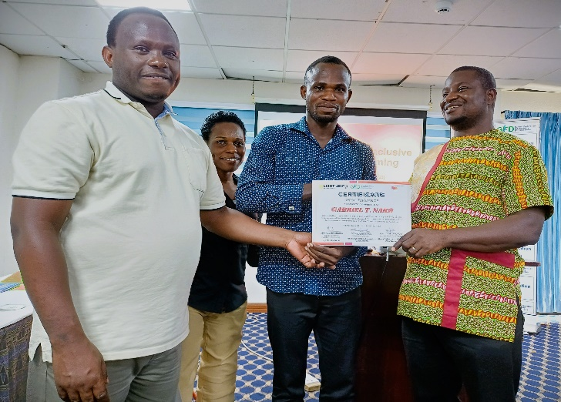
Throughout the training, staff from GFD, Light for the World, and guest facilitation from some Organizations of People with Disabilities (OPD) like the Ghana Blind Union (GBU), Mental Health Society of Ghana (MEHSOG) facilitated the engaging sessions, covering a wide range of topics. The DIFs will play a pivotal role in building relationships with young Africa works partners, serving as the link between persons with disabilities and GFDs public and private partners on disability inclusion.
The training equipped the DIFs with the necessary skills and knowledge to train and coach persons with disabilities and partners on disability inclusion. They
Facilitators presenting certificates to newly trained Disability Inclusion Facilitator
explored various facets of disability inclusion, comprehending accessibility requirements, and empowering youth and women with disabilities for employment opportunities. Additionally, the DIFs delved into important subjects like understanding disability models and the barriers faced by people with disabilities.
The significance of learning basic sign language was also emphasized, acknowledging its role in breaking communication barriers and ensuring that everyone's voice is heard and understood. Intersectionality, types of impairment, and physical accessibility assessment were also explored, providing valuable insights into promoting a world that embraces diversity and fosters inclusivity at all levels.
The trained Disability Inclusion Facilitators will serve as advocates for persons with disabilities and partner organisations on disability inclusion, collaborating with young African workers partners, and organizations to create a more inclusive and accessible work environment.

GFD and GIZ Collaborate to Train Paralegals to Advance the Rights of Persons with Disabilities
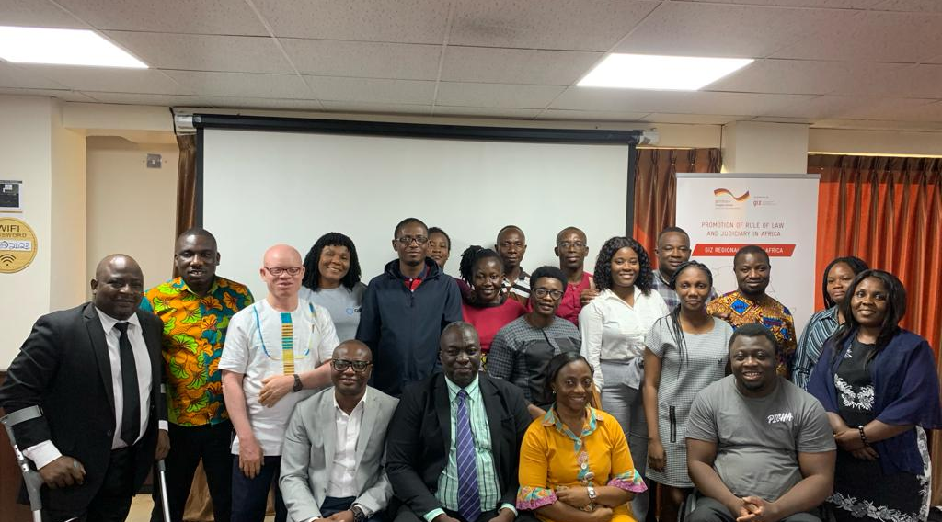
In furtherance of the partnership between GIZ and the Ghana Federation of Disability Organisations (GFD), a three-day workshop has recently been organised to promote the Rights of Persons with Disabilities by promoting access to justice. The workshop was held at the Alisa Hotel from July 18th to 20th, marking a significant step towards promoting inclusivity and equality in Ghana.
A group picture of LPoG members and Executives
The primary goal of this workshop was to train paralegals to acquire the knowledge and skills needed to advocate effectively for the rights of persons with disabilities in the communities. Topics covered included "Introduction to Paralegal Services," "Disability and Human Rights," "International Human Rights Instruments," "UN Convention on the Rights of Persons with Disabilities," and "National Laws - 1992 Constitution, Disability Act, and Labour Act."
The workshop was aimed to address the discrimination and marginalization that persons with disabilities often face, limiting their access to essential services and opportunities. GIZ and GFD joined forces to deepen the understanding of disability rights and the legal mechanisms that protect and empower persons with disabilities.
Throughout the event, participants from GFD, comprising selected staff and leaders of the member organizations engaged in in-depth lectures and interactive discussions. The resource persons were experienced lawyers with many years of disability rights advocacy who provided expert knowledge on local and international legislation concerning disability rights, the role of paralegals in the community, and understanding the complexities of accessing legal services.
The workshop emphasized international human rights instruments that form the foundation for protecting the rights of persons with disabilities. Special attention was given to the United Nations Convention on the Rights of Persons with Disabilities (UNCRPD), which sets a global standard for upholding the rights and dignity of persons with disabilities.
Beyond the global perspective, the training shed light on Ghana's legal landscape. Participants gained a comprehensive understanding of key national laws, including the 1992 Constitution, the Disability Act 2006 (Act 715), and the Labour Act of Ghana. This knowledge equips paralegals to advocate for policy changes and promote inclusivity across various sectors.
It is expected that the workshop will serve as a catalyst for change, inspiring a new generation of advocates who will be committed to advancing disability rights across the country. The exchange of ideas and experiences during the event is expected to have a profound impact on the lives of persons with disabilities, fostering a more inclusive and equitable society for all.

GFD Meets with the Speaker of Ghana’s Parliament to discuss amendment of Disability act.

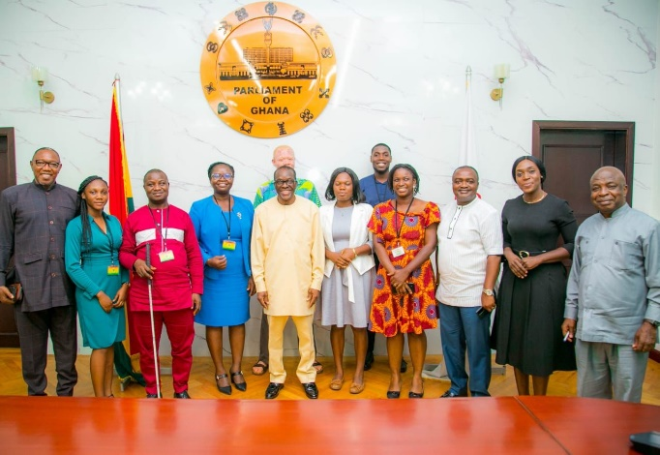
Speaker of Parliament, Mr Alban Bagbin said that parliament as an institution is committed to the cause of disability and inclusion in Ghana. “We need to have a number of physically challenged persons as Members of Parliament, it is one of the benchmarks for assessing parliaments in the world,” he said. Mr Bagbin made the remark when selected members of the disability movement and the Ghana Federation of Disability Organisations (GFD) paid a courtesy call on him. The Speaker of Parliament said: “we are working on all these things to make our parliament inclusive; we will do our best to inaugurate the disability caucus by the end of the year.”
The GFD is pushing for Parliament to have a formalized disability caucus that will support the disability movement in its advocacy and to help effectively monitor and contribute to the disability discussions on the floor of parliament. Ms Rita Kyeremaa Kusi, Executive Director of the GFD who led the delegation said there was the need for an enriched and enhanced conversation on disability issues at the parliamentary level. She called on the Speaker to help facilitate the re-enactment of the disability law to enable persons with disabilities to enjoy their rights in Ghana.
Ms Kusi also mentioned that Ghana has yet to ratify the African Disability Protocol (ADP), a protocol that considers African practices and concerns in dealing with disability issues. She said the process to sign and ratify the ADP started many years ago but there have been challenges and called on the speaker for support in the process.
Interim leaders of the disability caucus of parliament were at the meeting to lend their support. Dr. Emmanuel Marfo, Member of Parliament for Oforikrom Constituency, Mr Clement Apaak, Member of Parliament for Builsa South, and Ms Darkoa Newman, Member of Parliament for Okaikwei South, all pledged their unflinching support to the disability movement in Ghana. They also added their voice to the call for the formalization and inauguration of the disability caucus in parliament to enable them to do more.

Ghana Federation of Disabilities Organizations has Engaged with Educational Authorities on Inclusive Education Policy.

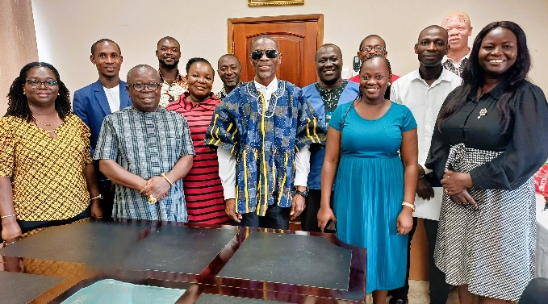
The Ghana Federation of Disabilities Organisations (GFD) recently met with key staff from the Ministry of Education (MoE) and the Ghana Education Service (GES) in a fruitful meeting.
The purpose of the engagement was to get updates on the inclusive education policy of 2015. This crucial policy outlines the strategic course for educating all children in Ghana in an inclusive environment together with children without disabilities. The Ghana inclusive education policy was developed through an extensive consultation process involving multiple stakeholders in the education sector, and it has been a pillar in the effort to pursue fair educational opportunities for all school children.
A picture of GES, and GFD Leaders
In attendance at the meeting were, the political leadership and program Managers of the GFD including Mr Joseph Atsu Homadzi, President of the GFD the Executive Director of GFD, Madam Rita Kusi Kyeremaa, the Monitoring, Evaluation, Research, Learning, and Adapting (MERLA) Manager, Moses Fordjour, the Programme Officer Abdul-Wahab Adam, the Learning and documentation Officer, Mohammed Lansah, and the National Coordinator of Inclusion Ghana, Mr. Jeleel Odoom.
The GES delegation included the Deputy Director Mr. Godwin-Godson Seli, Wilma Titus-Glover, the Principal Program Officer of the Special Educational Unit at the Ministry of Education, Madam Rose Ofosuhemaa Darko, and other key employees.
The President of GFD, Mr. Atsu emphasized the ongoing difficulties relating to the accessibility of suitable teaching and learning resources and a supportive learning environment for students with disabilities in Ghana. He agreed that although the essential modifications cannot be made right away, a group effort is required to openly discuss and deal with these difficulties.
Madam Rose Ofosuhemaa Darko agreed and emphasized how important it is to have reliable data to address the challenges identified by GFD. She illustrated the importance of budgetary allocations, highlighting the need for data to track and assess success. Although there is a goal to gradually boost budgetary allocation by 1.5%, Madam Darko explained that data is necessary to evaluate the success of these efforts, understand the true impact of funding schools, and meet learners' requirements. Regarding the complexities of the budgetary allocations to the GES, she clarified that many departments have their budgets, and only by working together with these divisions could comprehensive financial data be delivered.
Madam Darko emphasized inclusive education's broader breadth and clarified how it fits within the larger educational landscape.
The GFD's Executive Director, Madam Rita Kyeremaa, raised important issues regarding the comprehensive evaluation of schools' performance and the suitability of the national standard tests for documenting students' advancement beyond traditional measures. Mr. Jaleel Odoom stated a joint desire to do a more thorough assessment of the problem for the inclusive education policy to work effectively.
Mr. Atsu reaffirmed the GFD's shared commitment to increasing advocacy for more resources for the Ministry and the Special Education division to successfully implement the disability inclusion policy in a collaborative manner.
Moses Fordjour, the MERLA manager of GFD, emphasized that because inclusive education is under the Ministry of Education’s purview, the Ministry's financial support for the policy's implementation is something that should be taken into account and made clear for proper monitoring.
Madam Rose Ofosuhemaaa clarified the roles of the Ministry of Education and the Ghana Education Service, underscoring the distinction between policy formulation and implementation, while also noting that inclusive education is just one facet of the larger educational sector.
The meeting emphasized the importance of accurate data, collaborative efforts, and holistic perspectives to pave the way for inclusive education in Ghana.

Unlocking Opportunities for Entrepreneurs with Disabilities: GFD's Scoping and Barrier Analysis Study

In an initiative to promote inclusivity and empower persons with disabilities, the Ghana Federation of Disability Organisations (GFD) conducted a comprehensive scoping and barrier analysis study in the Eastern and Greater Accra regions from July 31 to August 9, 2023. This study not only sought to understand the challenges faced by entrepreneurs with disabilities but also aimed to gauge the perspectives of employers on hiring persons with disabilities. The findings from this pivotal research endeavour are poised to pave the way for the "We Can Work" project, scheduled for launch in 2024, in collaboration with "Light for the World" and supported by the Mastercard Foundation.
The impetus behind this study was to shed light on the struggles and hurdles faced by entrepreneurs who have disabilities in Ghana. Entrepreneurship, often seen as a gateway to economic independence and self-reliance, has not been without its unique set of challenges for individuals with disabilities. To provide tailored support and create an enabling environment for their entrepreneurial ventures, it was imperative to identify these obstacles.
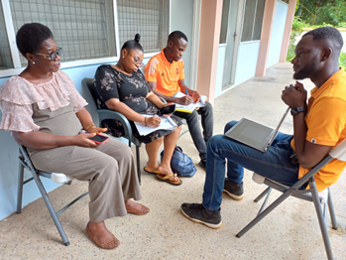
Simultaneously, the study aimed to capture the perceptions and attitudes of employers when it comes to hiring persons with disabilities. Despite the potential and untapped talents of this diverse group of individuals, misconceptions and biases have, at times, hindered their inclusion in the workforce. By understanding the employer's perspective, GFD is better equipped to develop strategies and initiatives that foster inclusive workplaces and promote the equitable employment of individuals with disabilities.
This study is a significant step towards dismantling the barriers that have limited the opportunities for people with disabilities in Ghana. It will not only provide essential data but will also serve as a foundational cornerstone for the "We Can Work" project, scheduled to pilot in 2024. This project, a collaborative effort between GFD and "Light for the World," with the generous support of the Mastercard Foundation, is poised to make a substantial impact in the lives of individuals with disabilities by creating inclusive spaces for meaningful employment, thus affirming their rightful place as contributing members of Ghana's workforce.

GFD Holds Reporting and Targeting Workshop for Staff
In a concerted effort to strengthen the reporting capabilities of its staff, the Ghana Federation of Disability Organisations (GFD) recently hosted a specialized Reporting and Targeting workshop. This training initiative, spanning three days, unfolded in the congenial setting of the GNAD conference room from August 7th to 10th, 2023, and witnessed active participation from 15 GFD staff members.
The primary objective of this workshop was to equip GFD staff with the necessary skills and knowledge to enhance their reporting abilities. Effective reporting is a fundamental component of any organization's operations, and for GFD, which is dedicated to advocating for the rights and well-being of individuals with disabilities in Ghana, it holds even greater significance.

During this comprehensive three-day training session, participants delved into various aspects of reporting, learning valuable techniques and best practices. They were guided on how to gather, structure, and present data effectively, ensuring that their reports are not only accurate but also concise and impactful. Targeting specific communication skills and approaches, the workshop aimed to empower GFD staff to convey their messages with clarity and precision.
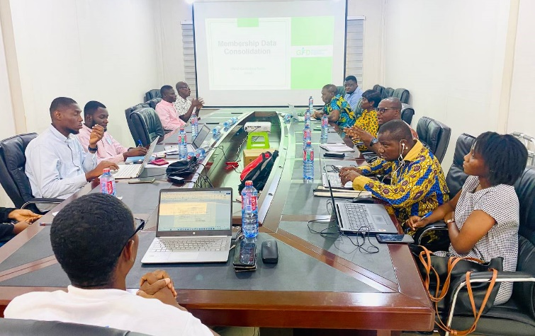
Enhanced reporting skills are pivotal for GFD as they serve as a linchpin in the organization's mission to effect positive change for the disability community in Ghana. Accurate, insightful, and well-targeted reports can help raise awareness, influence policy decisions, and mobilize resources to support GFD's programs and advocacy efforts. To address this challenge, the GFD Monitoring and Evaluation team organized a one-day workshop on the 8th of June 2023. The workshop took place at the Ghana National Association of the Deaf Conference room and brought together member organizations to discuss the importance of having a consolidated data system. The primary objective was to reach a consensus on a standardized template that would guide our data collection processes.
A group picture GFD staff at the training session

- Meeting with the Office of the Head of Civil Service
In a stride towards promoting inclusivity in employment, the Ghana Federation of Disability Organizations (GFD) convened a meeting on August 23, 2023, with the Head of Civil Service and other key personnel of his Office. The GFD emphasized its commitment to enhancing opportunities for its members and sought the guidance of the Civil Service in this pursuit.
The primary focus of the meeting was to address the challenges faced by graduates with disabilities in seeking employment within the Ghana civil service. Overcoming obstacles such as the lack of information on when the portal opens, and the absence of screen readers on the civil service application portal for visually impaired applicants has been a persistent hurdle. The GFD aimed to chart a way forward in collaboration with the Civil Service to rectify this issue.
Acknowledging the concerns raised by the GFD, Nana Kwasi Agyekum Dwamena, the Head of the Office of Civil Service, articulated the office's awareness of the difficulties encountered by persons with disabilities (PWD) in accessing the job portal. Dwamena disclosed that his office had been actively exploring solutions to address these challenges. Furthermore, he clarified that the volume of recruitments conducted annually depended on the number of financial clearances issued by the Ministry of Finance. In the present year, a hundred clearances were granted, signifying vacancies for a hundred potential applicants. Notably, Dwamena highlighted that the civil service had already recruited two PWDs in alignment with Ghana's inclusive employment policy.
Addis Ababa proved to be an excellent setting for our team to immerse themselves in the effective implementation of our methods. Equipping our team members with the necessary skills and knowledge was paramount to maximizing the project's potential and creating lasting change.
Elaborating on past initiatives, the Head of Human Resources at the Office of Civil Service Ghana revealed that between 2019 and 2022, the service successfully employed all PWDs who applied for available positions. Additionally, Mr Dwamena unveiled an existing collaboration with the Social Welfare department through a dedicated liaison officer, underscoring their commitment to PWD employment.
Proposing a comprehensive recruitment framework, Mr Dwamena suggested joint efforts between GFD and the Office of Civil Service to render employment and job applications more accessible for PWDs. He proposed that visually impaired candidates should be allowed to take recruitment examinations in Braille, thereby fostering a supportive environment from the application phase itself. Dwamena contended that addressing accessibility challenges would empower PWDs to compete on an equal footing.
Moses Fordjour, the Monitoring Evaluation Research Learning and Adaptation Manager of GFD highlighted the significance of information dissemination for PWDs. He stressed that as the umbrella organization for PWDs, the GFD was inundated with inquiries about the civil service recruitment process. Mr. Fordjour pledged the GFD's commitment to extending assistance in this regard.
To facilitate ongoing collaboration, the Head of the Office of Civil Service proposed the appointment of a dedicated liaison officer from GFD. This individual would regularly interact with the Civil Service to ensure open lines of communication and timely updates on the accessibility of the application portal. Moreover, the Head of Training and Development at the Office of Civil Service underscored the need for the GFD to forge a strong partnership with the social welfare department to streamline information sharing regarding the employment of PWDs.
Doris Ndebugri, the Programs Officer of GFD, raised critical requisites for visually impaired job candidates. She emphasized the need for extended time during recruitment exams and underscored the necessity of screen readers to navigate the examination portal effectively.
In a conclusive decision, a liaison officer was designated by the Office of Civil Service Ghana to collaborate closely with GFD in devising an inclusive recruitment framework. This collaborative effort aims to transform the landscape of PWD employment opportunities within the civil service, promoting inclusivity and equal access for all.
At GFD, we firmly believe in the power of knowledge sharing. Our team was enthusiastic about exchanging ideas and expertise during this visit, and the vibrant city of Addis Ababa provided the perfect backdrop for fruitful discussions. Together, we explored innovative ways to address the challenges faced by persons with disabilities.

- GFD Conducts Accessibility Training for Government Agencies

A training workshop held at the Sunlodge Hotel in Tesano, Greater Accra Region, on September 13, 2023, aimed to bolster accessibility and inclusion for persons with disabilities. This event was hosted by GFD and successfully brought together participants from various government institutions, equipping them with a comprehensive understanding of accessibility.
The workshop was structured into three informative modules. The first module delved into the concept of accessibility, highlighting its paramount significance for persons with disabilities. Participants were also given insights into the international and national legislation that governs accessibility.
The second module had a primary focus on recognizing barriers within the physical environment and presenting viable solutions to enhance accessibility. This module likely addressed practical challenges in making physical spaces more inclusive and accessible.

In the third and final module, participants were educated on how to conduct accessibility audits effectively. They were introduced to the essential tools and materials required for conducting such audits and gained familiarity with accessibility standards.

Diversity was a key feature of the workshop, with a total of 32 participants in attendance, comprising 18 males and 15 females. These participants represented various government institutions, including the Ministry of Local Government and Rural Development, the National Planning Development Commission, National Council on Persons with Disabilities, among others.

The inaugural remarks were delivered by Rita Kusi Kyerema, the Executive Director of GFD, setting the stage for the workshop. Rebecca Efua Nunoo, the Disability Inclusion Advisor, assumed the role of session moderator, fostering a sense of connection and engagement among participants. Facilitators Gideon Segbe and Moses Fordjour, with additional support from Nora Kankam Dadzie, led sessions and encouraged participants to engage in discussions and practical applications throughout the training program.

The training program stood out for its active participation and a strong commitment to learning, creating a dynamic and collaborative learning environment. Positive outcomes of the workshop encompassed the training of government agencies on the Ghana Accessibility Standard for the Built Environment. Demonstrations were also made to illustrate how accessible environments significantly enhance inclusion. Additionally, the workshop provided an outline of the processes involved in conducting accessibility audits

The GFD convenes meeting with regional leaders

The meeting, which took place on September 22, 2023, saw the Vice President of GFD opening the session with an introductory statement, underscoring the urgency of the gathering. The focus of the meeting was to address pressing concerns regarding the National Health Insurance Scheme (NHIS) registration.

The officer responsible for NHIS membership registration of GFD provided an update to the participants, revealing that only 8% of the intended target of 800 individuals had been successfully registered or had their cards renewed. This low registration rate was met with disappointment among the participants.

The floor was then opened to participants, allowing them to share their concerns about the NHIS registration drive.

During the discussions, the Accra regional leader requested a detailed breakdown of the regions registered. Although the Greater Accra region had submitted their members' names for NHIS registration, they were yet to receive the registered cards. Furthermore, it came to light that the Oti Region had submitted 32 names to the federation, but none of them had been successfully registered, highlighting a significant challenge in the NHIS registration process.

The meeting concluded with a commitment from all parties to address these issues and improve the NHIS registration process for the benefit of all members. The meeting served as a step toward resolving the challenges facing the NHIS registration system within the GFD.

Capacity Gaps Training for 3 OPDs – MEHSOG, GAPA, GBU

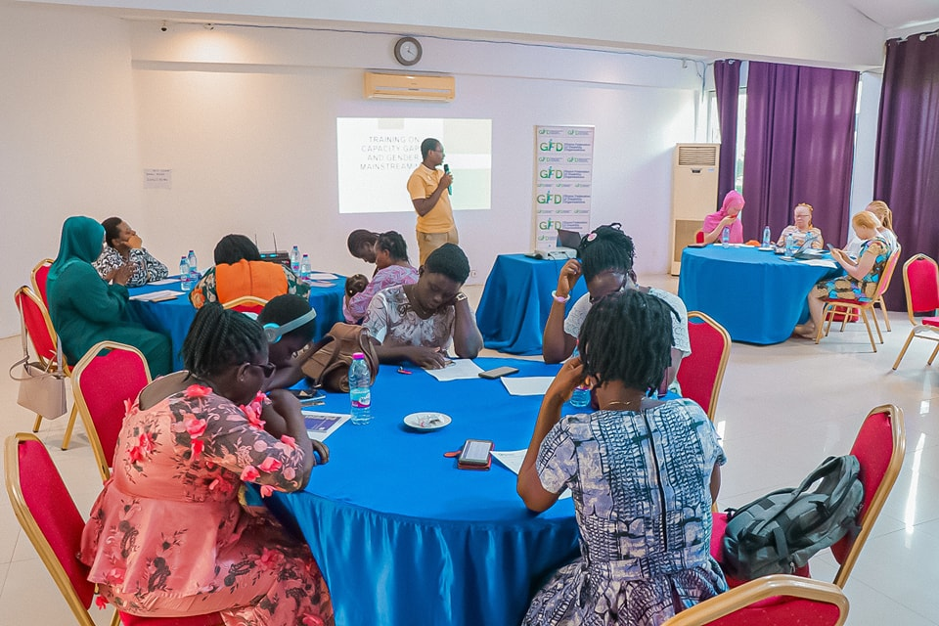
The Acknac Hotel in East Legon, Ghana, hosted a successful three-day training program on gender mainstreaming from September 27 to September 29, 2023. The Ghana Federation of Disability Organisations (GFD) organised the program, which was designed especially for the female wings of three organisations for people with disabilities (OPD). The program sought to give participants the skills and information needed to address gender-related issues in their projects and organisations. Participants took part in several incisive conversations, interactive activities, and team-building exercises over three days, establishing this program as a key step toward advancing gender equality and inclusivity.
A picture of women receiving training
The first day of the training program set the stage for a comprehensive exploration of gender mainstreaming. Participants delved into gender awareness, perceptions, and knowledge, gaining a deep appreciation for the intricacies of gender-related issues. Engaging discussions provided a platform for participants to share their perspectives and experiences, fostering an understanding of the subject matter. This day also featured sessions on sex, gender, and sexuality, emphasizing the importance of distinguishing between these concepts when designing inclusive and gender-responsive projects.
A highlight of Day 1 was a hands-on exercise in body mapping and understanding the concept of gender. This activity encouraged participants to examine their own perceptions of gender and consider how these perceptions may vary among individuals. The results of this exercise were both eye-opening and thought-provoking, offering valuable insights into the diversity of gender perspectives within the group.
The second day of the training program delved into gender roles and responsibilities, highlighting the importance of recognizing and addressing these dynamics within OPDs. Participants gained a deeper understanding of the intersection of gender and disability, acknowledging the unique challenges faced by women with disabilities.
Additionally, the day featured a stimulating game on gender models, providing participants with a practical and interactive way to apply their newfound knowledge. This hands-on approach allowed for the exploration of various gender models and their relevance in different contexts.
The third and final day of the training program expanded upon the foundation laid in the previous two days. The topics covered included an exercise on barrier analysis of gender mainstreaming, which enabled participants to identify and address obstacles to gender equality in their respective organizations and projects. Additionally, the day delved into gender mainstreaming strategies and tools, equipping participants with practical skills to implement gender-responsive practices. The session concluded with a discussion of best practices in organizational gender mainstreaming efforts, offering valuable insights and inspiration for participants to take back to their respective organizations.
The Ghana Federation of Disability Organizations, in partnership with the Disability Rights Fund (DRF), is committed to promoting gender equality and inclusivity. The three-day gender mainstreaming training program served as a step toward achieving these goals. By empowering the women's wings of disability organizations with knowledge, skills, and a collaborative network, the GFD is paving the way for more inclusive and equitable programs and projects that benefit individuals with disabilities and society as a whole. The success of this training program underscores the importance of ongoing efforts to advance gender mainstreaming and disability rights in Ghana.

Capacity Assessment Workshop Empowers Women's Wings of Disability Organizations.

The Capacity Assessment workshop was organised by the Ghana Federation of Disability Organisations (GFD), in collaboration with the Disability Rights Fund (DRF). The workshop, held from June 26 to 28, 2023, brought together the women's wings of three disability organizations in Ghana - Ghana Blind Union (GBU), Ghana Association of Persons with Albinism (GAPA), and the Mental Health Society of Ghana (MEHSOG). The primary objective was to conduct a comprehensive assessment of the capacities of the women's wings and identify areas for improvement within their respective organizations.
Throughout the workshop, meaningful discussions took place, addressing the crucial challenges faced by women with disabilities. By creating a safe and inclusive space for dialogue, participants were able to openly tackle the issues that hinder the full participation and empowerment of women within the disability community.

The collaborative efforts of GFD and DRF in organizing this workshop underscore their commitment to advancing gender equality and the rights of women with disabilities. By fostering an environment of inclusion and empowering women within the disability movement, they are working towards a more equitable and inclusive society.

We commend the women's wings of GBU, GAPA, and MEHSOG for their active participation and engagement in the Capacity Assessment workshop. Their dedication to driving positive change and amplifying the voices of women with disabilities is truly commendable.

Success Story!

"Empowering Diversity: The Success Story of Azuleloanu's 10-Room Guest House"

In 2017, Ellembelle District recognized the importance of economic inclusion and improving the quality of life for people with disabilities. Disability rights advocates joined forces with district officials to pursue this vision by tapping into the District Assemblies Common Fund. Their goal was to construct a 10-room guest house in Azuleloanu, creating a space that would benefit the entire community.

With the necessary funds secured, the district chapter of the Ghana Federation of Disability Organisations (GFD) and district officials collaborated on a well-organized project to bring the guest house to life. First, they acquired suitable land for the project, ensuring a prime location for the venture.

The "10-room Guest House" quickly became an integral part of the community, representing a powerful initiative with numerous positive impacts. One of its most significant achievements was promoting empowerment and inclusion. The Guest House was designed to be accessible to all community members, including those with disabilities, the elderly, and marginalized groups. Inclusivity and diversity were embraced, creating a safe and welcoming environment for everyone.

Beyond social benefits, the guest house also made a considerable economic impact. By attracting visitors and fostering cultural tourism, it indirectly contributed to the growth of the local economy. Additionally, the Guest House provided resources and opportunities for entrepreneurship and job-seeking, further uplifting the community.
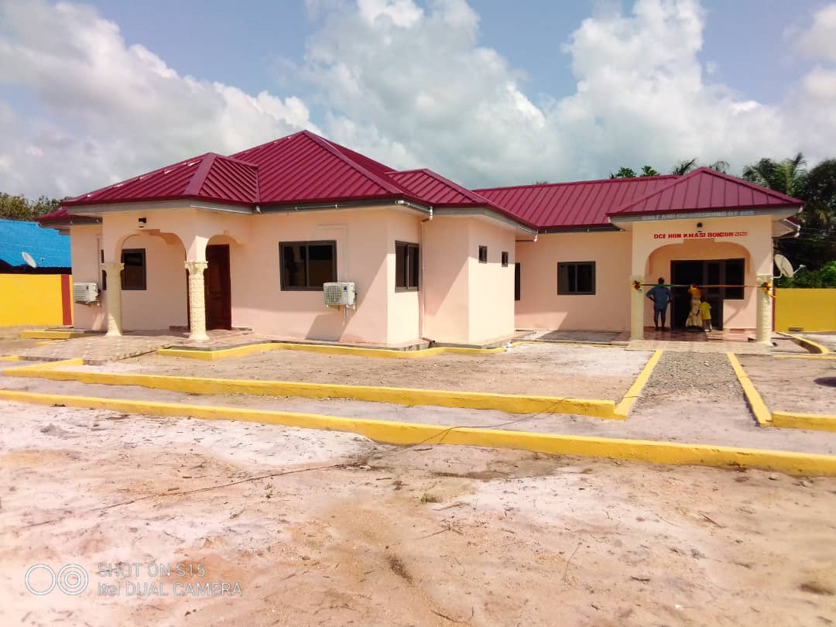
The success of the "Guest House" is a testament to the power of effective fund utilization, inclusive consultation with people with disabilities, active community involvement, and strategic planning. Through this approach, the thriving and impactful guest house in Azuleloanu became a reality, exemplifying the true potential of collaborative efforts and conscientious planning in enhancing lives and fostering economic growth.

